OSFI B-13 Compliance for Log360
Automate OSFI B-13 compliance and fortify cybersecurity resilience for financial institutions.
Region: Canada | Type: Financial Services, Cybersecurity Framework, Government/Public Sector, Incident Management, Operational Resilience | Category: Compliance | Pricing: Free

Overview
The OSFI B-13 compliance extension in Log360 helps organizations meet OSFI Guideline B-13, the technology and cyber risk management standard from the Office of the Superintendent of Financial Institutions for federally regulated Canadian financial institutions effective January 2024 by providing centralized log management, MFA-aware identity monitoring, and continuous threat detection. The platform supports OSFI B-13 requirements for cyber risk governance, technology asset management, identity and access control with MFA, vulnerability defense, security logging, incident response, and business continuity.
For Technology and Cyber Risk Governance, Log360 monitors AD logons, GPO changes, user auditing, and policy events to provide audit evidence of governance structures and risk oversight activities. To address Technology Operations and Asset Management, the platform monitors Windows program inventory, services, computer account changes, network device configurations, and backup/restore events to validate operational asset and change management practices. The extension also supports Identity and Access Management with MFA by providing capabilities that monitors AD and Windows logon events, failed authentication, user account changes, Entra MFA activity, and PAM usage to validate layered access controls.

Key Features
- Vulnerability Management and Cyber Defense: Log360 collects Windows and Unix threat detection, network attack and security logs, firewall events, and vulnerability scanner results to demonstrate a layered defense posture.
- Security Logging and Threat Detection: Log360 aggregates Windows event logs, system events, process tracking, network attack, firewall, and Entra risky sign-in alerts into a centralized view for SOC-level monitoring.
- Incident Response and Forensics: Log360 captures signals from FireEye, Trend Micro, McAfee, Windows threat detection, cloud security incidents, and Microsoft Defender to support full incident lifecycle management.
- Business Continuity and Disaster Recovery: Log360 monitors backup/DR policies, infrastructure events, job completion, malware detection in backup systems, and DR IAM activity to verify continuity control effectiveness.

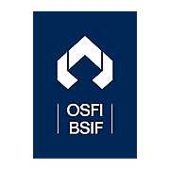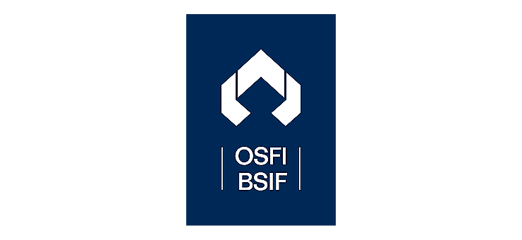

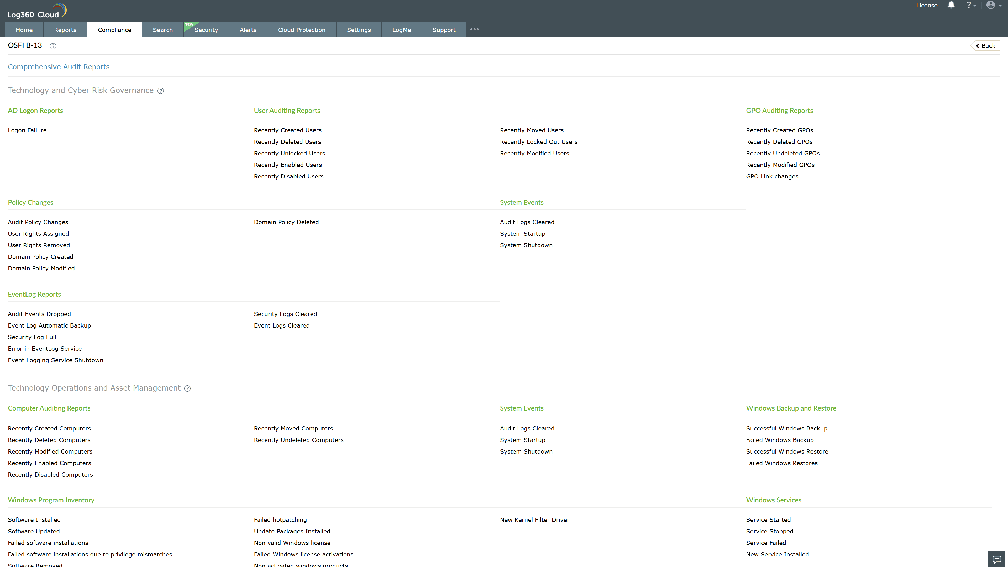
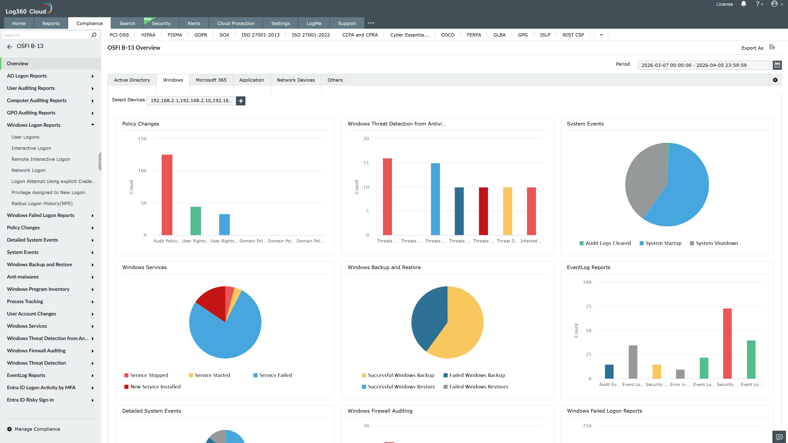
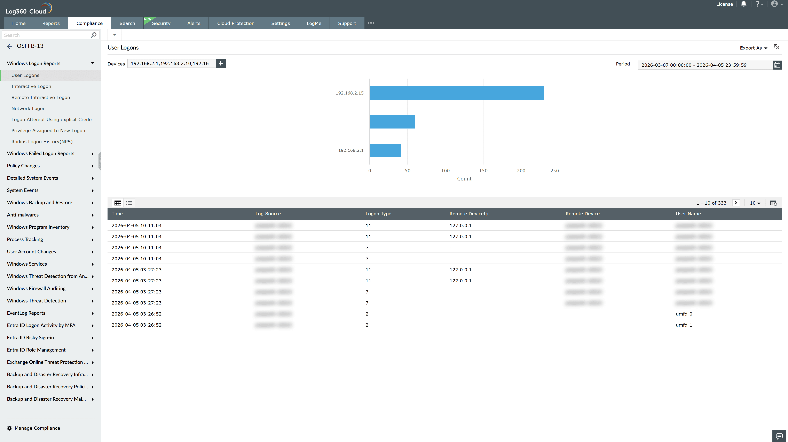
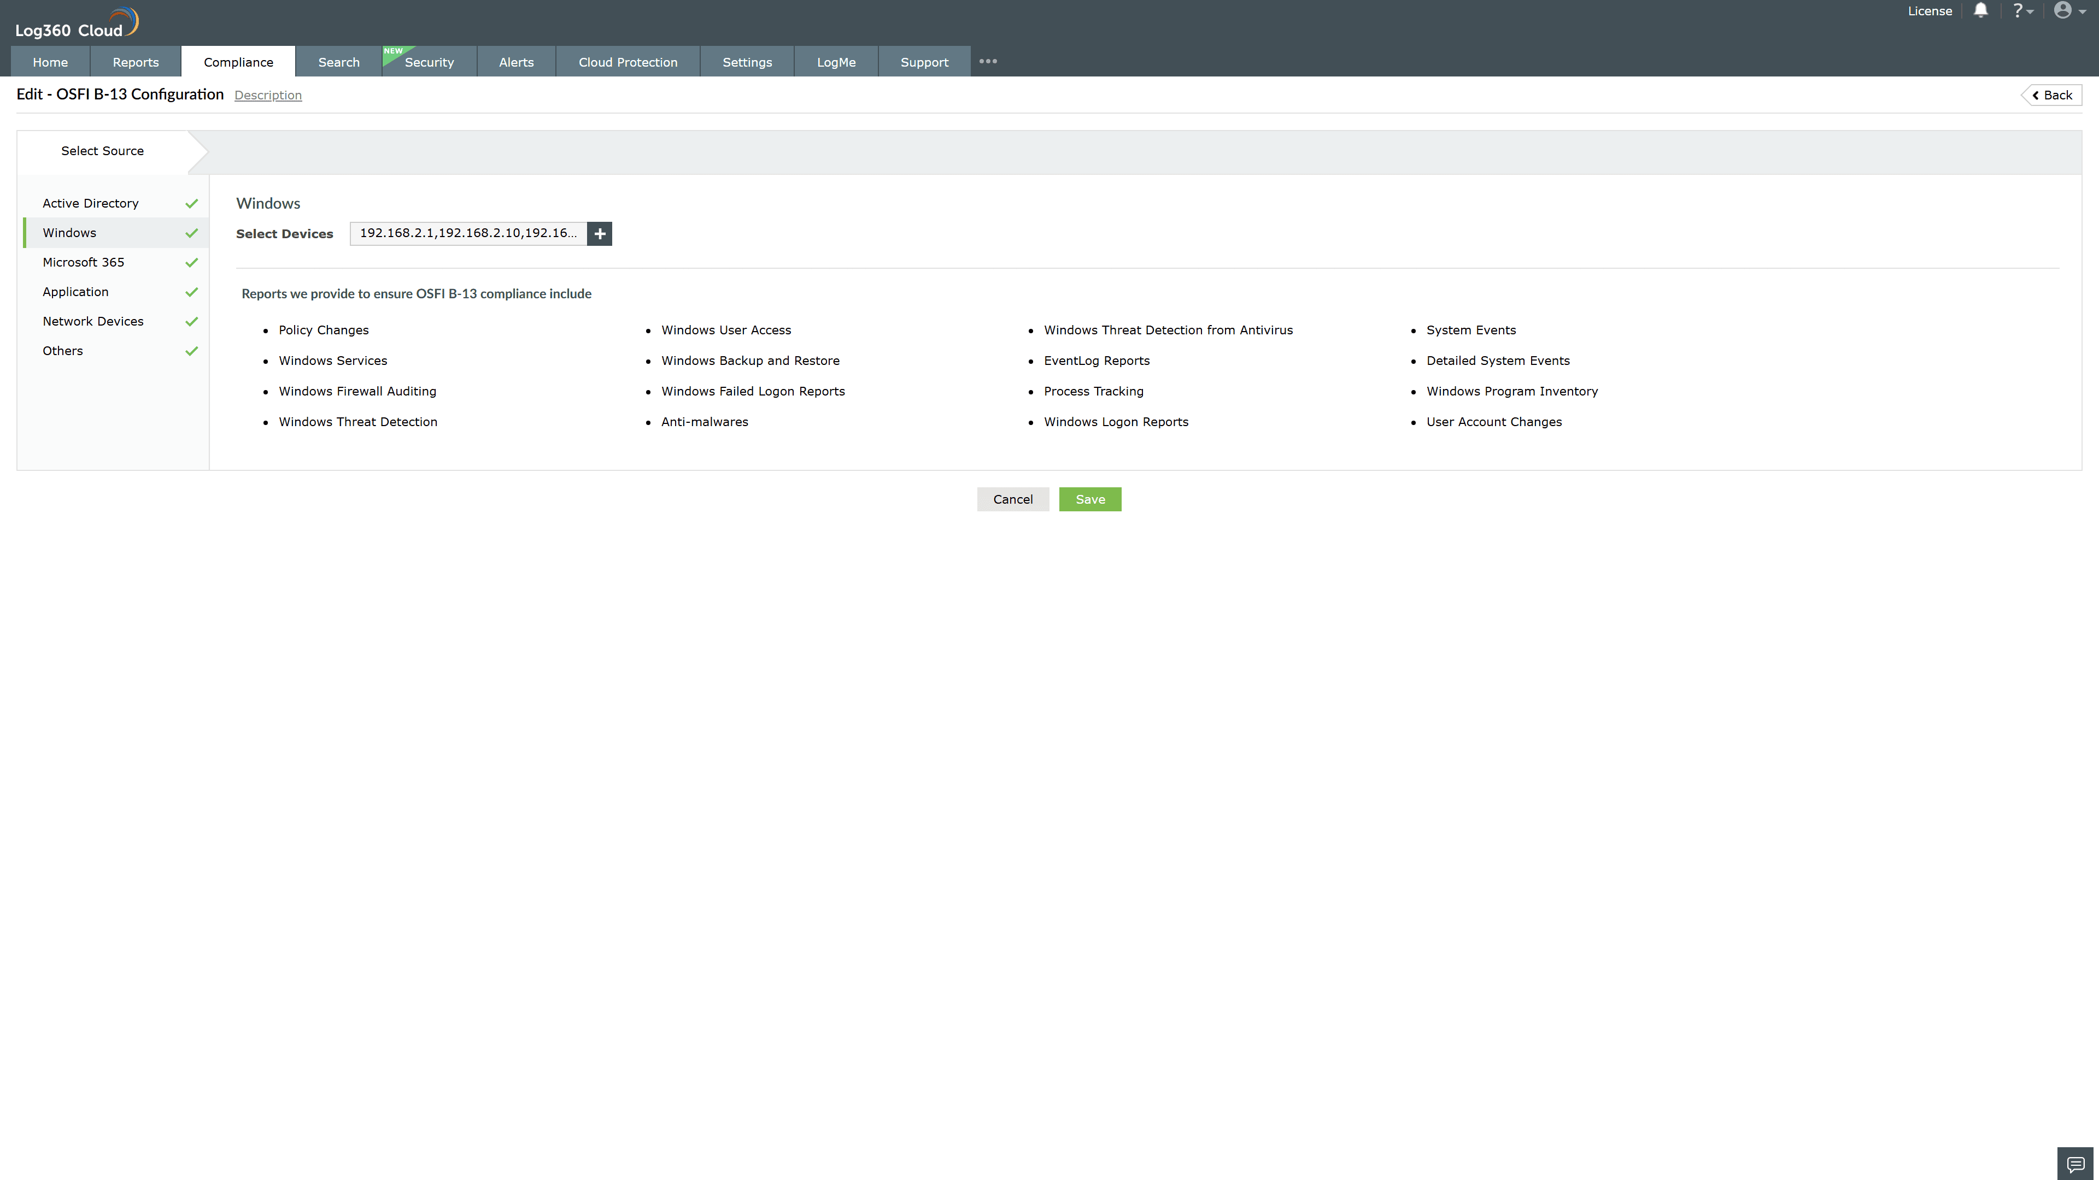
Valid Submission : Yes
Supported Editions : Free, Basic, Standard, Professional, MSSP
Help Document : https://www.manageengine.com/log-management/help/integrations/compliance-extensions.html
Help Video : Not provided
Tags : Log360, Compliance, Privacy monitoring, Data privacy, Regulatory compliance
Supported DCs : US, IN, JP, CA, AU, UK and EU
Privacy Policy:
Terms of Service:
Release Notes:
Predefined reports for the OSFI B-13.

